PICK CITY NEWS

JUNE 2025



City of Pick City meeting minutes June 4, 2025

Present: Mayor Arvid Anderson, Lori Davis, Scott Bather, Kel Westman & Brandon Reiser.

Also Present: PWD Jim Sailer, Attorney Mark Kaffer, Vernon Herman & auditor, Diane Johnson

Mayor Anderson called the meeting to order at 7:30pm

Davis motioned, Bather second to approve consent items: agenda, bills, and minutes of the May 7, 2025 meeting. All in favor.

Westman motioned, second Reiser to approve the 1’ variance for the Fire Hall addition. Upon roll call vote, all voted yes. Motion carried.

Westman motioned, second Reiser to approve of the Beer & Liquor (On & Off sale) licenses for the Dam Bar & Little’s Bar & Grill and the Beer & Wine (off-sale) license for Scott’s Bait & Tackle. All in favor.

Reiser motioned, second Davis to approve the Street dance at Little’s Bar on June 28th. Fencing will be installed around the area. All in favor.

Bather motioned, second Davis to approve the “moving out & in “building permits for house #2025-5 & pole barn # 2025-4 on Donny Wald’s property and Chuck Able’s moving in new mobile home #2025-6. All in favor.

Chicken ordinance was handed out for council to review. No one attended meeting that was interested in raising chickens in town. No action taken.

AirBnB sample ordinance was tabled.

Lauren Donovan is planning a small wedding at her Airbnb, council had no concerns other than following noise ordinance.

Attorney Kaffer update the council on the nuisance property. He will reach out to owner with a time line and if no action is taken by owner, he will gets bids for abatement and it will be assessed to owner’s taxes.

Mr. Kaffer updated the council on residents with no water service. He has been in contact with Western Plains Health, they will enforce, with the authority of NDCC 23-35-09.

Streets: Council agreed to have PWD Jim order 6 loads of milled asphalt & 4 loads of gravel.

Landfill: Reiser suggested to let the public know that there is firewood that can be cut at Landfill.

Park: Bather turned wood chips and checked playground equipment. Porto-potty has arrived.

There being no other business meeting was adjourned at 8:20pm. Next city meeting July 2, 2025

General Fund: Payroll/ins./reimb. $3441.35; Circle-2456.00; DOC-34.84; Hardware Hank-76.74;

Menards-92.39; Amy Ones-850.00; Scott’s-115.91; WRT-125.40, RRE- 647.39; IRS-$1335.10;

NDPers-243.00. Water: Payroll -$1410.50; J. Sailer-50.00; NDDEQ-50.00;

MSRWD-3413.04; NDDH-54.00; WRT-31.65; RRE-378.63. Sewer: Payroll-$705.20, USPS- $392.00.

**NOTICES:**



FIREWOOD

Available to cut at Pick City Landfill

Please call City Hall

487-3327



**City of PICK CITY FIREWORKS NOTICE**

Fireworks are permitted in Pick City limits on the following dates:

**July 3rd & July 5th from 10:00am to 12:00 midnight**

**July 4th from 10:00am to 1:00am**

All rubbish related to fireworks must be cleaned up.

The explosion of any fireworks is strictly prohibited when a burn ban is issued.

**The use of the type of balloons which require fire underneath to propel the same are prohibited at all times.**

**The discharge of fireworks is prohibited in any public area including City Park**

Any combustible or explosive composition, or any substance or combination of substances or article prepared for the purpose of producing a visible or an audible effect by combustion, explosion, deflagration or detonation, and includes blank cartridges, toy pistols, toy cannons, toy canes, or toy guns in which explosives other than toy paper caps are used, , firecrackers, torpedoes, skyrockets, roman candles, day go bombs, sparkles or other fireworks of like construction, any fireworks containing explosive or flammable compound, or any tablets or other device containing any explosive substance. Nothing in this regulation may be construed as applying to toy paper caps containing not more than twenty-five (25) hundreds of a grain (16.20 milligrams) of explosive composition per cap.

**We encourage you to be mindful of others who may be affected by fireworks**

**(Veterans, pet owners, shift-workers, children…)**

**Thank You and Happy 4th of July**

PICK CITY



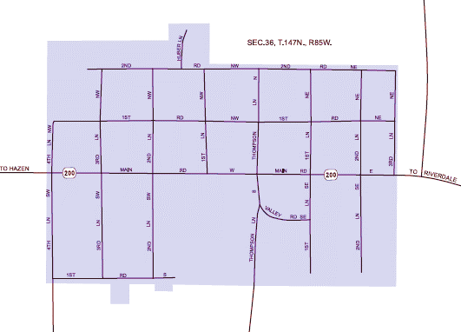

JUNE 20-21-22

**⑥**

**①**

**②**

**⑧**

**⑦**

**③**

**④**

**⑨**

**~~⑤~~**

**#1 Ness** – 221- 2nd Rd NE (in alley) – June 20-3:00-? & June 21 – 9:00 -?

**#2 Sailer** – 72 Thompson Lane N – June 21-22 – 9:00 - ? “Garage & household clean out”

**#3 Dissell** – 21-3rd Lane SW – June 20-21 – 7:30am – 5:00.

**#4 Shirley** – 83 – 3rd Lane SW – June 20, 21 – 9-3:00

**~~#5 Salveson~~** ~~– 272 – 1~~~~st~~ ~~rd. SW –~~ CANCELLED

**#6 Griwzow** – 68 -2nd Lane SE – June 20, 21, 22 – 9:00 – furniture, Honda 1982 motorcycle, misc.

**#7 Ellwein** –135 – 1st Lane NW- June 20 – 3:00 - ? June 21- 9:00am, June 22-9:00 – 12:00 “Shop cleanout” air compressor, tools, 4 wheeler, ect.

**#8 Johnson** – 55 2nd Rd NW -June 20- 3:00pm-? -June 21, 22 – 9am-?

**#9 Reinholt** – 330-1st Lane NE – June, 20, 21, 22 – 9am -? Lots of stuff~!

More may pop up watch for signs