
Pick City News
April 2026

City of Pick City April 1, 2026 meeting minutes
Present: Arvid Anderson, Lori Davis, Brandon Reiser, Scott Bather. Absent: Westman
Also present: Auditor, Diane Johnson
Mayor Anderson called the meeting to order at 7:30pm
Pledge of Allegiance was recited.
Rieser motioned, second Davis to approve consent items; meeting minutes from 3-4-2026, agenda & bills. All in favor, MC.
Reiser motioned, second Davis to hire S & M Lawn Service to spray town, cost will be the same as last year. All in favor, MC.
Board of Equalization meeting will be held April 8, 2026 at city hall.
Attorney was not present to discuss unresolved previous concerns & issues, but did sent some paperwork requested by council for the Wald annexation. No action taken.
Reports:
Landfill: Spring cleanup will be April 28 – May 5. Roll offs will be at landfill.
Water: Pick City received a Safe Drinking Water Act Certificate of Achievement from NDDEQ.
Water break by Main Road has been repaired, PWD Sailer was not present to explain breakage.
The mayor thought the City should implement a plan to exercise curb stops when Hydrants are flushed.
Streets: Jim contacted Tand construction for a timeline to repair the street up at the Wald addition.

There being no further business, meeting was adjourned at 8:00pm. These minutes are unofficial and subject to Council review and approval. Next regular city meeting May 6th at 7:30pm.
Bills: Payroll - $5861.03, D. Johnson-36.25, J. Sailer-50.00, NDPERS-234.00
US Treasury-1406.25, Job Service -12.68, WRT-178.02, RRE-1457.15
Circle-2311.25, Dust Tex-53.90, Fitterer Oil-616.00, Drain man-14,606.25
Fergusion-332.94, Hazen Star-75.00, Lillis Elec-517.00, Loffer-39.83
MC Treasurer-1150.00, API Garage door–1415.80, NDDOH-54.00, ND One Call-1.50
NWPE-437.00, One’s Consulting-1200.00, Scott’s-109.00

Calendar of Events 2026

April 8 – Board of Equalization meeting – 1:00pm @ City Hall
April 15 – Final Steering Committee – 6:30 pm @ Center
April 28 – Spring Cleanup for PC residents (by noon roll offs will be here) to May 5th
May 9 – Apehangers- “Hot Rod at the Hatchery”- Car show -12:00pm @Garrison Dam Fish Hatchery
May 23- Hatchery Fun Day – 9:00-1:00 @ Garrison Fish Hatchery info: 654-7475
May 23rd – EMS for Kids – 4:-8:00pm @ Fort Stevenson State Park – Garrison
May 25th memorial day – City offices closed
June 20th – Little Bar & Grill Street Dance & Fireman’s Fundraiser.
June 25- 28th – Mercer County Fair.


We want to set up City wide rummage sales again, then following we will have the Park Fundraiser.
Tentative dates
June 19 & 20th for City wide
July 10, 11, 12 for Fundraiser.
*Need ideas*
If you are interested in the city wide
Please call Diane 487-3327
To put you can be on the map



Why do bees have sticky hair?
Because they use a honeycomb!

What do you call a bee that can't make up its mind?
A Maybe
2026
Dog
Licenses
DUE
Dog
License
Are due

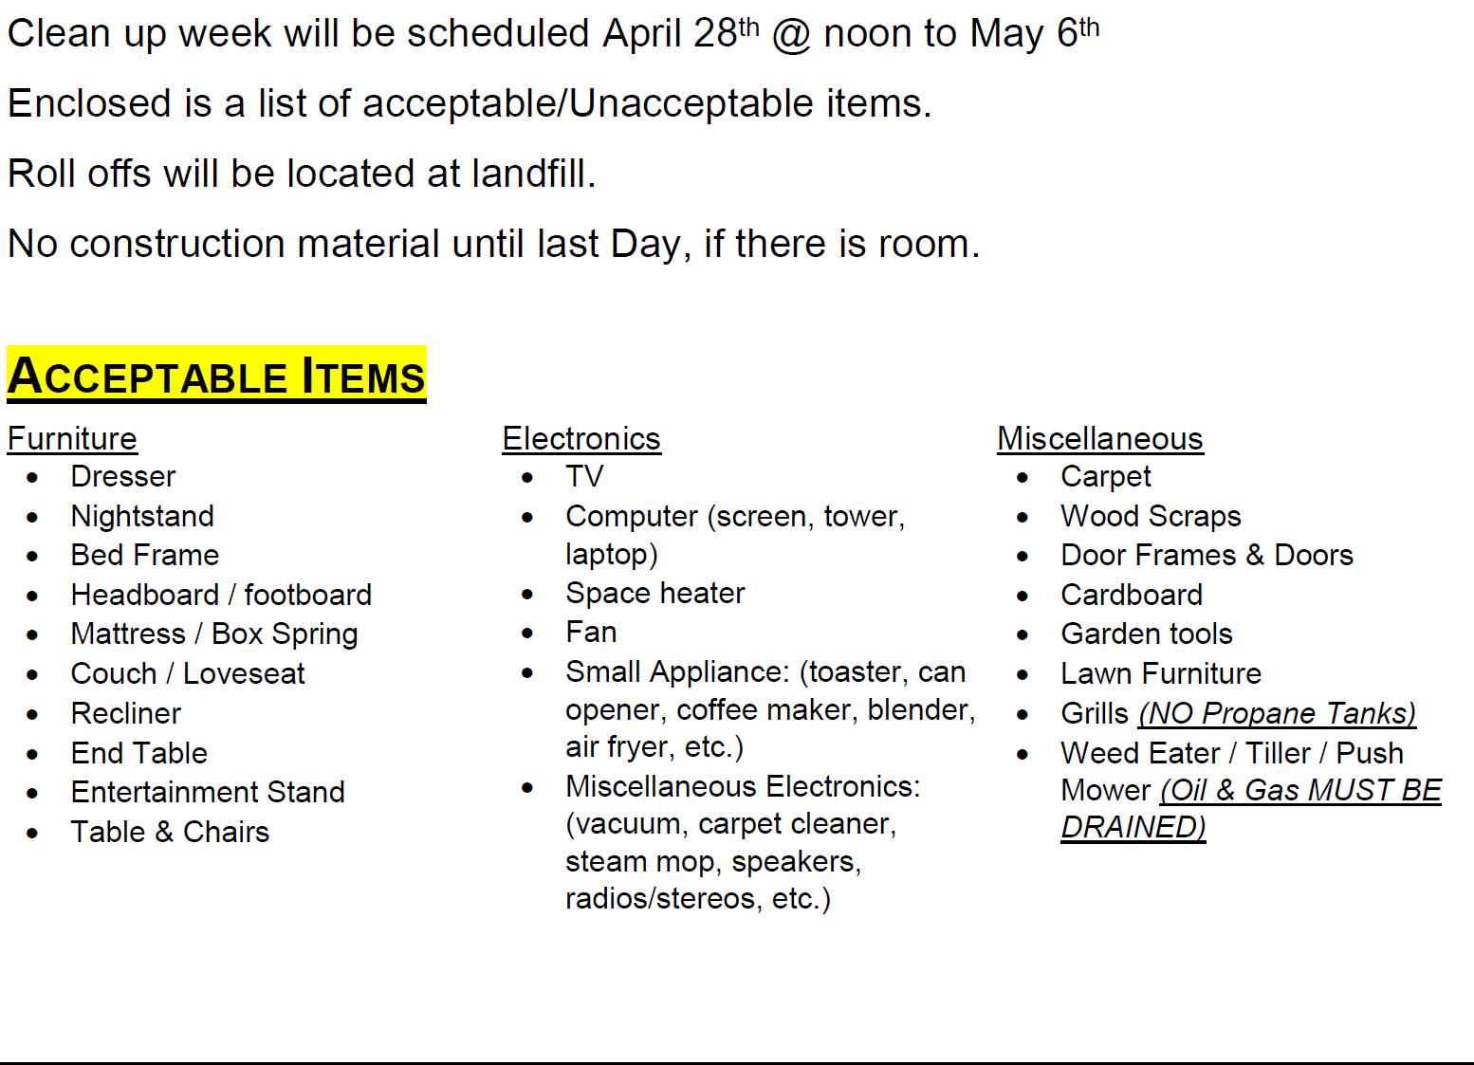
5

North Dakota City Fun Facts
- 355 incorporated cities in North Dakota.
- 77% of North Dakotans live in cities, representing an estimate 613,000 citizens.
- 377,774 acres of land are within city boundaries.
- $4.9 Billion + is the value of city-owned property.
- 9,924 people are employed by cities.
- 150 cities have adopted Home Rule Charter.

